**REACT**

**Handson 1**

Create a new React Application with the name “myfirstreact”, Run the application to print “welcome to the first session of React” as heading of that page.

**Steps:**

1. Install Create-react-app by running the following command
2. To create a React Application with the name of “myfirstreact”, type the following command:
3. Open the folder of myfirstreact in Visual Studio Code
4. Open the App.js file in Src Folder of myfirstreact
5. Remove the current content of “App.js”
6. Replace it with the following:

**App.js**

import React from 'react';

function App() {

  return (

    <div>

      <h1>Welcome to the first session of React</h1>

    </div>

  );

}

export default App;

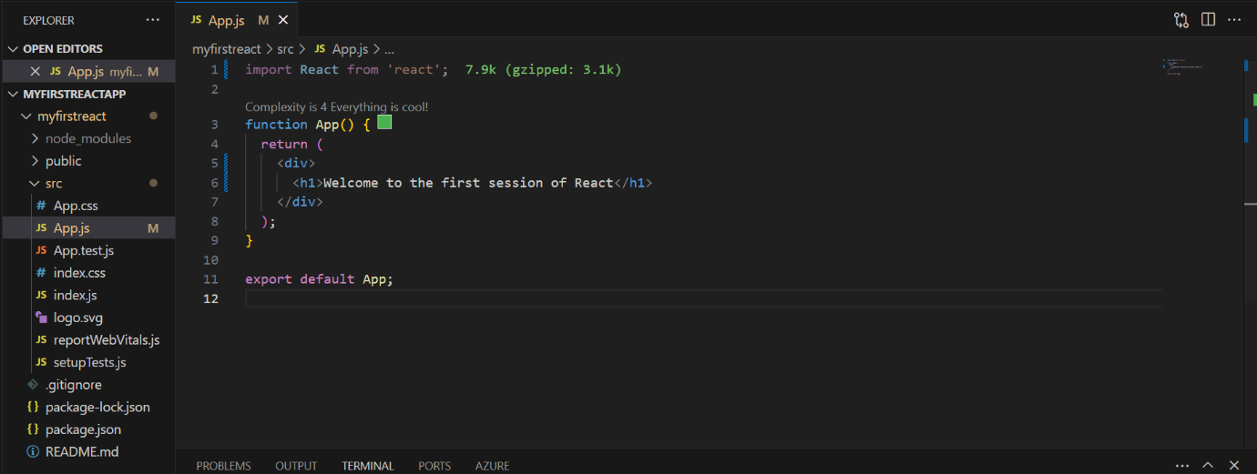

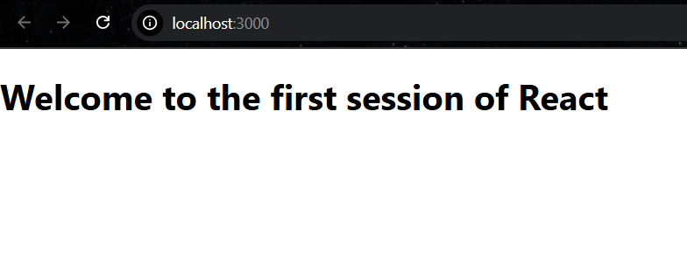**Output:**